Does Protein Affect the Metabolic Rate of ZebraFish
Statement of the Problem
Dietary ingredients, and nutrients as well as anti-nutritional remain important factors that affect its growth and development. However, there lacks proper nutritional control due to the absence of standardized reference diet (Boyle et al. 5354). Moreover, numerous epidemiological studies undertaken indicate that several prenatal are important in the growth and development of Zebrafish (Daniorerio)(Acheson et al. 456) As a way of providing a standardized dietary framework, a need emerges for the provision of specific dietary and nutritional standard aimed at improving the growth and development of Zebra fish. Thus, the necessity to investigate the growth and metabolic rate of Zebrafish (Daniorerio) when fed with different commercial diets.
BACKGROUND
The consumption of proteins in a diet could have significant effects on the body metabolism. The high calories contents of proteins commonly require more calories for breakdown that carbohydrates and this could have significant effects of various metabolic aspects. The amount nature of proteins makes them significantly different from other dietary constitutes that people consume routinely. In general, proteins cause an increase in the metabolic rate of organisms because of a variety of reasons Like for instance, Weight maintenance is actually a simple matter of the energy balance and also energy balance is attained when "energy in" is corresponding to "energy out
Thermic affects accounts for the numerous ways in which proteins increase the metabolic rate of the body. Due to the strong bond making the protein molecules, a lot of energy is required to break down the high protein that has been consumed. The thermic effect of proteins means that about 30% of the calories in proteins are burned in the process of digesting proteins(Acheson et al. 528). The heat generated in the process increases the general body heat output hence influencing metabolism.
The consumption of protein in diet has been established as a factor that increases the metabolic rate in human beings (Howard et al. 117).This is mainly because proteins require a lot of energy to be broken down and the body must provide such energy, hence it increase the metabolic rate. The process of protein synthesis in the body causes the amino acid structures of the proteins consumed to begin the process of building body muscles. The construction of these tissues in the body is a process that consumes high amounts of energy hence the body requires increased energy to undertaken the process. As a result on the increased energy requirements, high metabolic rate occurs in order to maintain the required amount of energy necessary to sustain the activities of breaking down amino acids to form muscle tissues.
Within marine environments, hypoxia episodes remain prevalent due to a variety of reasons. The presence of oxygen within the marine environment affects the physiological functions of organisms residing within these conditions. Like many other organisms, during the process of respiration, fish taken in oxygen and give out carbon dioxide. As water flows through the gills of the fish, the oxygen in the water diffuses into the circulatory system of the fish and simultaneously carbon dioxide diffuses out of the fish body.
The metabolic process in fish requires consumption of oxygen and the conditions of hypoxia cause fish to stop feeding and reduce movements as they seek to conserve the energy that they have. The minimum requirements of the dissolved oxygen for tropical fresh water fish like Zebrafish is 80% saturation. Any level below this can be considered as hypoxia. The levels of oxygen in the water, hence affect the metabolic rate of the fish in a directly proportional manner. Since fish require oxygen for metabolism process, low levels of dissolved oxygen will result in low metabolic rate. This is an adaptive technique that the fish take to prevent them from dying due to the lack of oxygen.
STUDY SPECIES
Zebrafish (Daniorerio) describes a small shoaling fish which belongs to the minnow family of Cyprinadaeand order cypriniformes. It is a tropical fish that resides in fresh water conditions and is a native species of the Himalayan region. Due to its unique characteristics it possesses, the Zebrafish remain vastly utilized as a vertebrae model organism in scientific research. It has regenerative characteristics and has been modeled by various researchers to produce numerous transgenic strains. Zebrafish have been utilized in numerous medical research studies and findings relating to various human diseases. These include cancer prevention, cardio-vascular diseases as well as investigating immune systems and other drug discovery systems
Furthermore, because of their omnivorous characteristics, they are have been extensively utilized in environmental monitoring activities as a way of preventing water pollution by estrogen (Howard et al. 1173). Based on past literatures and research studies investigating the growth and metabolic rate of Zebrafish (Daniorerio), they are imperative in conducting studies in the development, genetics as well as the human disease conditions(Williams, Mirbahai, and Chipman 157).
HYPOTHESES, GOALS, AND OBJECTIVES
Proteins in the body of living things have different effects on the physiological functions of body. Metabolism refers to the process that involves chemical reactions essential for the maintenance of the living state of organisms. It is a process that is closely linked to nutrients and the presence of nutrients significantly affects the functioning of the body. Nutrients are an essential part of the metabolic process as they provide the essential energy required for metabolism to continue. The major elements of a diet include carbohydrates, lipids and protein and each plays an important role in the metabolic process.
In the process of metabolism, proteins are necessary because they contain amino acids. They are the main body building tissues and hence have a significant role in the metabolic rate and all this will be said in detail in the entire research.
Proteins are important body building components and their consumption in a diet could have a significant impact on the metabolic rate of organisms. With the relevance of the proteins and the significant role that they play in the metabolic process, it would be expected that would present a positive impact on increasing the metabolic rate of the Zebrafish as well. The experiment will be seeking to establish the effects of protein on the metabolic rate of the Zebrafish as per the hypothesis formulated from the extensive research conducted on the effect of proteins on metabolism. High diet proteins have been found to increase the metabolic rate of many organisms due to the nature of the structures of amino acids, which are the main components of the proteins and this also happen to Zebra.
The experiment focuses on the developing a test that can be utilized to assess the impact of dietary proteins on the metabolic rate of Zebrafish. Based on the hypothesis, the experiment will be seeking to establish whether the consumption of proteins which increases the protein level of Zebrafish, can increase the metabolic rate in these organism measured on the basis of the oxygen level within the environment where the fish reside. The goal of the experiment can be described as:
Testing the metabolic rate following the application of 6 different protein levels available in commercial diet by measuring the oxygen level in Zebrafish
The hypothesis of this experiment forms the basis upon which the testing will be conducted to determine the expected outcome. By testing the hypothesis, the following objectives have been developed for the study
- To determine the existing relationship between the protein level and the metabolic rate in Zebrafish
- To determine the protein level at which maximum metabolism can be achieved by the organism in the study
THE EXPERIMENT
The experiment will be conducted using three different groups of Zebrafish placed in provided with six different types of commercial feeds with the same levels of fat and fiber but varying protein content. The main reason for the grouping of the organisms into three groups is to ensure the assessment of the effects that the various available commercial feeds can have on the metabolic rate based on the differences in the protein levels in the food. The available commercial feeds have formed the guideline for undertaking the research since the levels of protein and other nutrients are established by the manufacturers.
Each of the three groups will be provided with a food that has a specified level of fat and fiber with varying protein levels. The inclusion of three groups ensures that the impacts of the other nutrient on the metabolism process will not affect the results of the experiment. All nutrients play a part in the metabolism process, and although the research seeks to determine the impact of protein, the effects of the other nutrients present in the food cannot be ignored. Consideration of the facts that these other nutrients also affect the metabolism process is the primary reason for the grouping of the organisms according to the levels of fat and fiber present in food.
The tables below indicate the groups of organisms and the type of feed provided to them
Group 1
Name | protein | Fat | Fiber
Nutrafin Max Flake Food | 44% | 5% | 2%
Tetra Pond Koi Vibrance | 31% | 5% | 2%

Group 2

Name | Protein | Fat | Fiber
TetraMin Tropical Flakes | 38% | 6% | 6%
HBH Algae Grazers | 28% | 6% | 6%

Group 3
Name | Protein | Fat | Fiber
New Life Spectrum Premium | 48% | 5% | 4%
Dainichi Veggie Deluxe | 28% | 5% | 4%

METHOD
A total of 3 water tanks will be utilized and 6 male Zebrafish. Each tank will content two Zebrafish and they will be provided with two different types of feeds to determine the hypothesis that has been established for purposes of this study. The grouping allows for feed with the same levels of fiber and lipids and varying proteins to be provided to the groups and results to be assessed.
The activities which the fish undertake commonly consume energy and could have a significant impact on the oxygen levels that will be utilized in determining the metabolic rate. There are significant discrepancies in activities of Zebrafish in terms of behaviors based on the gender. These behaviors include swimming and movements which are sex-specific characteristics that can be utilized to assess the fish(Lee, Green, and Tyler 128). In seeking to cater for the existence of these differences, same sex fishes will be utilized in order to minimize the possibility of sex-related behaviors affecting the findings.
Anxiety linked behaviors among the fish have been observed in past experiments and these could affect the outcomes of the experiment if different sexes of fish are used in testing. Female Zebrafish have been found to have higher glucose utilization that males, when put in the same environment(Ampatzis and Dermon 387). The metabolic differences in the sexes of fish could be attributed to the observed behavioral discrepancies between the female and male organisms.
The study specimen who will be provided within each of the tanks will be of similar physical traits in order to cater for difference in metabolism that might be caused by differences in physical characteristics like size and age. Similarities in these traits which also affect the metabolism rate will ensure that these physical attributes do not affect the outcome of the research findings(Augustine et al. 277). While the nutrients have significant impact on the metabolisms rate other physical attributes of organisms also present a significant impact on the metabolic rates as well.
Indirect fluorescent lighting will provide an equal light to dark photoperiod of 12 hours. Temperature within the experimental environment will also be monitored daily using a thermometer (Fisher Scientific, Pittsburgh, PA). The levels of Ammonia-nitrogen, pH and NO2-N will be assessed weekly using a standard aquarium pharmaceuticals test kit (Aquarium Pharmaceuticals, Chalfon, PA). Each tank will contain one cylindrical plastic mesh cage (0.25 m height by 0.09 m diameter) that will be covered with nylon mesh (Fashion Knee Hi; American Corporation, Henderson, NC). Temperature must be maintained at 28°C (±0.5°C), pH between 8.0 and 8.4, and ammonia-nitrogen and NO2-N, contained below visual detection limits.
Metabolism is a process that is affected by a myriad of external factors other than the nutrition and bodily constituents in terms of muscle, age, body size and others. Temperature of the environment in which the organisms are residing should be similar to ensure that the differences observed are not as a result of the other factors. The monitoring of temperature seeks to ensure accuracy of the results as a slight change in temperature could affect the metabolic rate adversely(Kim et al.).
While the organisms are maintained in similarity, the environment of the experiment should also be similar in seeking to minimize the effect of environment induced metabolic differences. The levels of oxygen can also be affected by the external environment like the presence of other gases within the environment hence the tanks in which the experiment will be conducted must be maintained in an enclosed state(Vergauwen et al. 153). There are many other factor which could influence the outcomes and hence the accuracy of the results requires development of testing environments in which many of these factors are controlled 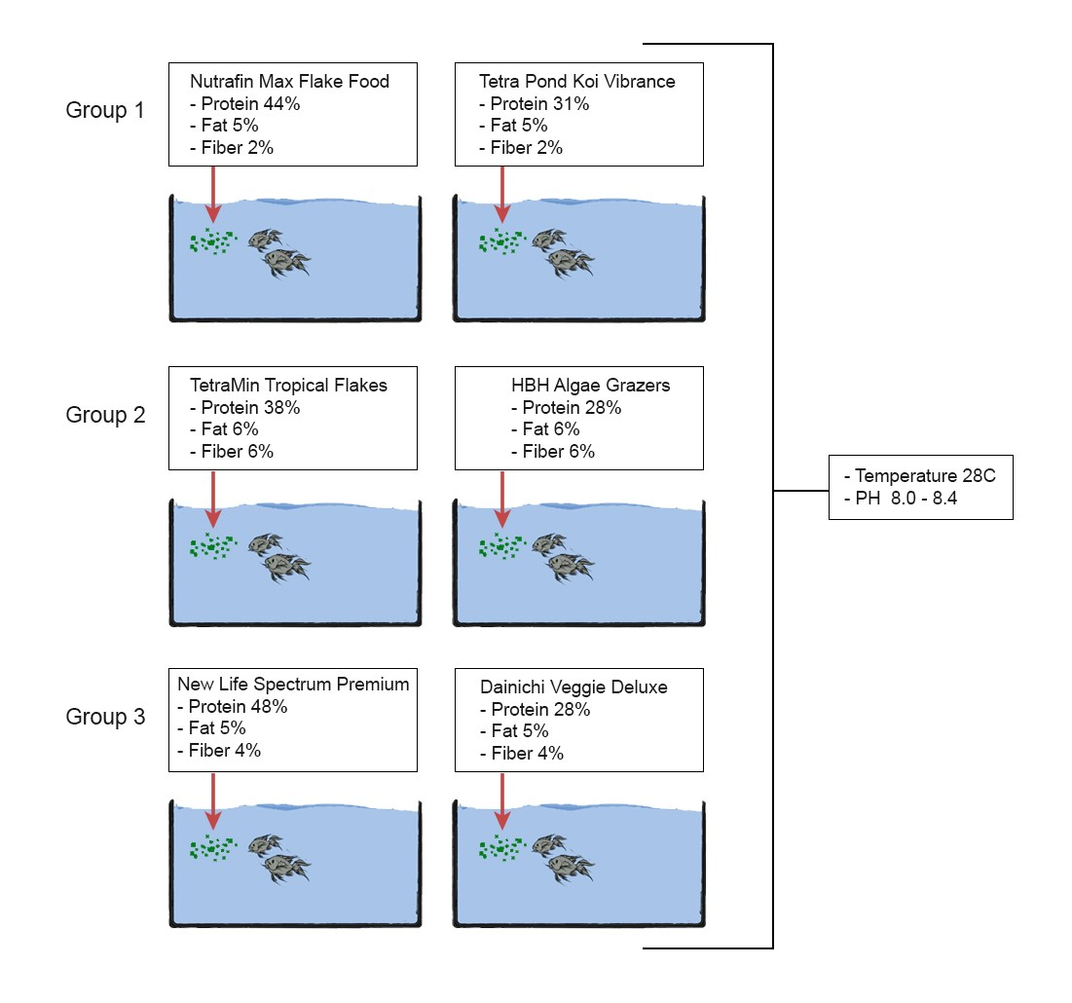
Figure 1
Figure 1 shows number of tanks and fish that will be used in this experiment, and type of food that will be giving to each group of Zebrafish.

Outcomes
There are various elements which will be measured in seeking to provide analysis of the experiment and consequently test the hypothesis of the research
Dissolved Oxygen (DO)
The Salifert Oxygen Test Kit will be utilized in the assessment of the DO values. This kit provides a quick and accurate test for assessment of dissolved oxygen content. The proper oxygen concentration is essential for aquarium inhabitants and the general welfare of the aquarium environment. The Salifert Oxygen Profi Test is extremely fast and provides a professional measurement of dissolved oxygen. Maintaining proper oxygen levels remains important in marine aquariums due to the low solubility of oxygen in saltwater. The Salifert Oxygen Test Kit is necessity test kit for hobbyists who have sophisticated aquarium devices such as calcium reactors, CO2 systems, or ozonizes, in which regular monitoring of oxygen level is crucial.
Significance and impact
This research experiment seeks to determine the impacts of high protein diet on the metabolic rate of Zebrafish. While many of the nutrients available in food have significant impact in the metabolism process, proteins have a complex structure which causes them to require high amounts of energy to be processed. It is presumed that the high protein compared to low one in diets increase the metabolic rate of Zebrafish. This research will provide significant information to the numerous individuals who are involved in the rearing of Zebrafish for different uses. The knowledge gained will be critical in aiding them to understand the kind of food that they can provide to the fish to achieve maximum metabolism, which is critical in providing necessary energy for the growth (Sisman et al. 794).
The research adds to the existing body of knowledge on the metabolism of Zebrafish. These organisms have been extensively studies and utilized in many medical experiments. They thus, forman important part of scientific research and through the results of this research, the knowledge available will be expanded(Varshney and Burgess).The broader ecosystem requirements of the fish will also be understood. The research forms the basis upon which other components of the diet like carbohydrates can be studied for the impact on the metabolic rate to be determined.
Statistics
T-test and Analysis of Variance abbreviated as the ANOVA are two parametric statistical techniques that are used to test the hypothesis. because these are based on the universal assumption like the population from which the sample is drawn should be usually distributed, homogeneity of the variance, random sampling of the data, independence of the observations, measurement of the dependent variable on the ratio or even interval level, people frequently misinterpret these two. The t-test and ANOVA look at whether group means vary from one another and also the t-test compares two groups, while the ANOVA can do more than two groups, (Varshney and Burgess).

References
Acheson, Kevin J. et al. “Protein Choices Targeting Thermogenesis and Metabolism.” The American journal of clinical nutrition 93.3 (2011): 525–534. Print.
Ampatzis, Konstantinos, and Catherine R. Dermon. “Sexual Dimorphisms in Swimming Behavior, Cerebral Metabolic Activity and Adrenoceptors in Adult Zebrafish (Danio Rerio).” Behavioural Brain Research 312 (2016): 385–393. Print.
Augustine, Starrlight et al. “Developmental Energetics of Zebrafish, Danio Rerio.” Comparative Biochemistry and Physiology Part A: Molecular & Integrative Physiology 159.3 (2011): 275–283. Print.
Boyle, David et al. “Natural Arsenic Contaminated Diets Perturb Reproduction in Fish.” Environmental science & technology 42.14 (2008): 5354–5360. Print.
Howard, Richard D. et al. “Mate Competition And Evolutionary Outcomes In Genetically Modified Zebrafish( DanioRerio).” Evolution 69.5 (2015): 1143–1157. Print.
Kim, M. J. et al. “Behavioral Changes Of Zebrafish According To Cisplatin-Induced Toxicity Of The Balance System.” Human & Experimental Toxicology 33.11 (2014): 1167–1175. Print.
Lee, Okhyun, Jon M. Green, and Charles R. Tyler. “Transgenic Fish Systems And Their Application In Ecotoxicology.” Critical Reviews In Toxicology 45.2 (2015): 124–141. Print.
Sisman, Turgay et al. “Single-Cell Protein as an Alternative Food for Zebrafish, Danio Rerio: A Toxicological Assessment.” Toxicology and industrial health 29.9 (2013): 792–799. Print.
Varshney, Gaurav Kumar, and Shawn Michael Burgess. “Mutagenesis AndPhenotyping Resources In Zebrafish For Studying Development And Human Disease.” Briefings In Functional Genomics 13.2 (2014): 82–94. Print.
Vergauwen, Lucia et al. “Long-Term Warm or Cold Acclimation Elicits a Specific Transcriptional Response and Affects Energy Metabolism in Zebrafish.” Comparative Biochemistry and Physiology Part A: Molecular & Integrative Physiology 157.2 (2010): 149–157. Print.
Williams, Tim D., Leda Mirbahai, and J. Kevin Chipman. “The Toxicological Application OfTranscriptomics And Epigenomics In Zebrafish And Other Teleosts.” Briefings In Functional Genomics 13.2 (2014): 157–171. Print.

